High Volume Oil Pump Instructions

Installing a high volume oil pump may be the most important modification you can make to your engine, seeing that a high volume oil pump will deliver MUCH more oil to your top end. The best time to install a high volume oil pump is while installing a bore kit as this will save you a lot of time. Please note that installing a high volume oil pump requires a 2mm drill bit. The following instructions assume that the top end has already been removed.

- Drain the engine oil if you have not already done so.
- Remove the right side engine cover.
- Remove the clutch linkage. Use a clutch nut tool to remove the clutch nut and remove the clutch assembly. The oil pump can now be accessed.
- Use an impact driver to carefully loosen the screws on the oil pump.

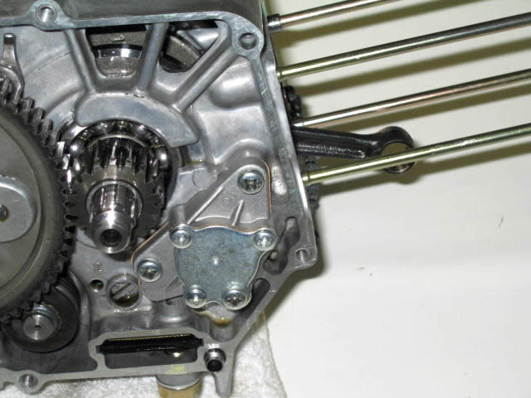

- Remove the old oil pump and you are now ready to drill out the oil passage.

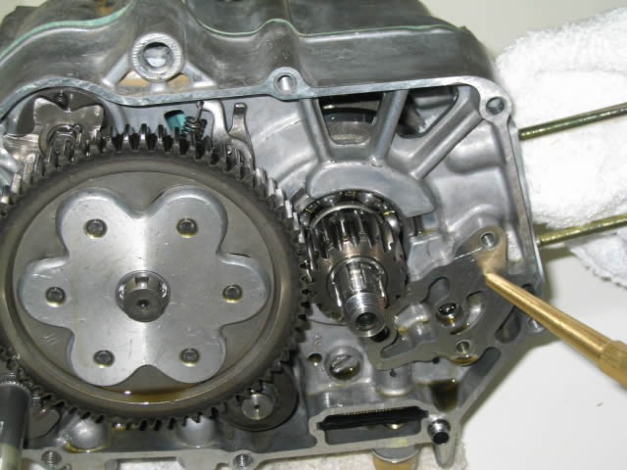

- In order to access the oil passage, you can either remove the lower left engine stud or you can simply use a drill bit extension.
- Use a 2mm drill bit to CARFULLY enlarge the oil passage. Be careful to not drill to far back into the engine. You only need to enlarge the hole.

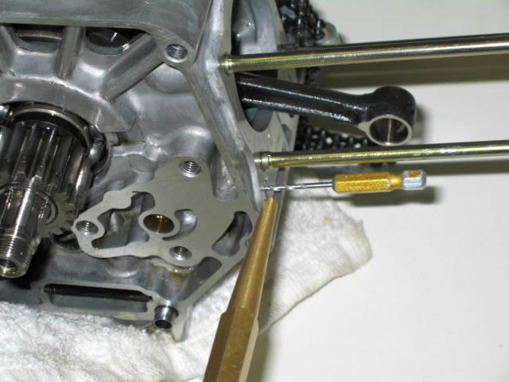

- After the hole has been drilled, use compressed air and a rag to be sure that ALL of the drill bits have been removed.
- Install the new oil pump and gasket. Make sure that the notch on the oil pump lines up with the notch on the engine case.

- Turn the sprocket to make sure that the oil pump spins.
- Reinstall the clutch assembly.
- Reinstall the right side engine cover.

